* **[How to upload a document](https://sharepoint.rackspace.com/learning/articles/Pages/SharePoint--2013-How-to-upload-a-document.aspx)**

For this example we will be showing you how to simply upload a document to the Out of the Box Document Library.

1. From the quick launch click **Documents**.

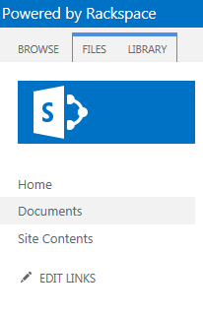

2. From your local computer find the document you want to upload and drag it to the SharePoint document library where it says "**drag files here**"

3. Notice the section will become highlighted and it will say "**drop here…**", release the document.

4. After a few moments the document will be uploaded!

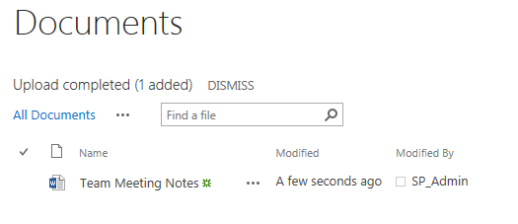

This works for uploading multiple documents as well.

5. Again, navigate the documents on your local computer drag them all to where it says "**drag files here**".

6. Once the section becomes highlighted and says "**drop here…**" release the documents.

7. After a few moments all of the documents will upload and you can easily start collaborating with your team.

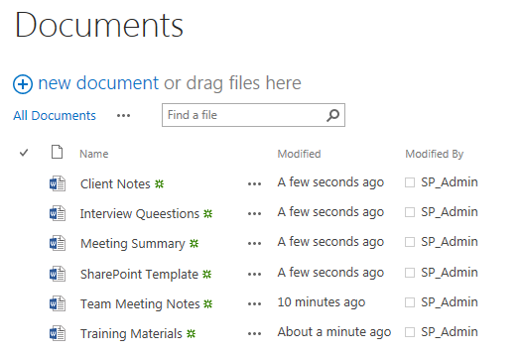

Special Notes:

When uploading documents to SharePoint there are a few limitations in the file name length as well as the special characters.  Please s​ee our FAQ for more details about file name length and special characters.